WrapStyle Cairo – Empyrean Enterprises
Cloud Nine Mall, Mohamed Naguib Axis, New Cairo


Cairo, Egypt
+2012 00 999 333
Monday, February 16, 2026 – 3:33 PM

Payment Receipt

Transaction | #
Payment Method | ☐ Credit Card – ☐ Cash – ☐ Bank Transfer – ☐ Cheque
Customer Name
Car Make & Model
Service | Paint Protection Film  ☐ Partial – ☐ Full Wrap Excluding Roof – ☐ Full Wrap Including Roof  Thermal Insulation Window Film  ☐ Partial – ☐ Full  Vinyl Color Wrap  ☐ Partial – ☐ Full  ☐ Windshield Protection  ☐ Car Screen Protection  ☒ Other:

Issued by:

Reminder
• Schedule a visual inspection within 7 days of installation. Complimentary inspections are recommended every 6 months.
• If you notice any problems or defects, contact the WrapStyle customer service team immediately.
• Do not wash your wrapped vehicle for 3–5 days & do not wash or roll down tinted windows for 48 hours post installation.
• Bubbles may appear & will usually disappear within 1-2 months. Do not puncture, press, or try to fix the bubbles yourself.
• Avoid high-pressure water jets, as they can damage the film.
• For hand washing, use soft microfiber towels only. Replace each towel monthly and use it for one vehicle only.
• Polishing: Do not use polishing machines — they cause color loss and scratches.
• Do not wipe or scrub the film in direct sunlight or while it’s warm.
• Use only WrapStyle-approved cleaning materials. Unapproved products can cause discoloration or permanent damage.

Regards,
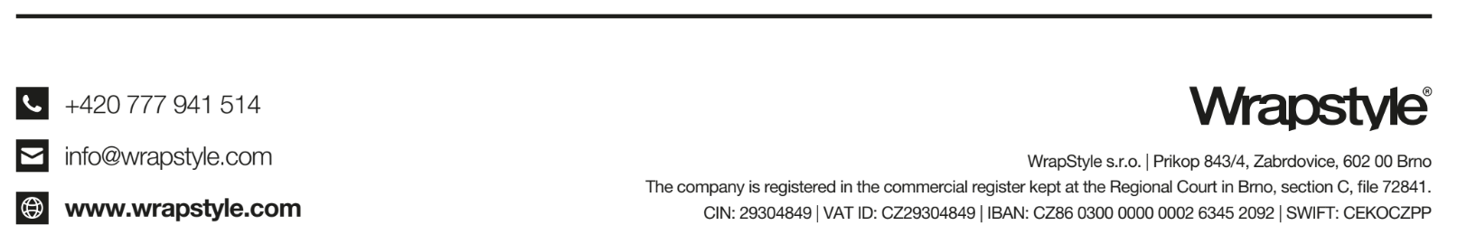

The WrapStyle Team
+2012 00 999 333
cairo@wrapstyle.com
Empyrean Enterprises
Mohamed Naguib Axis, Cloud 9 Mall, New Cairo, Egypt
Tax ID: 555-579-042

